Opis: Opis: Opis: Opis: Opis: Opis: Opis: cid:image001.png@01D2C87D.F83C8A30

*ICC BELUX RUSLAND & OEKRAINE*

Rotary clubs ANTWEPEN RING & WEST

*Save the date*

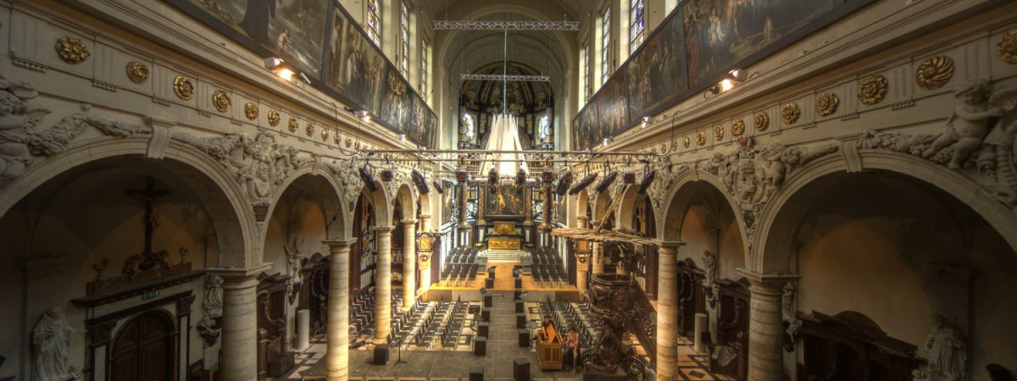

**INTERNATIONAL PEACE CONCERT**

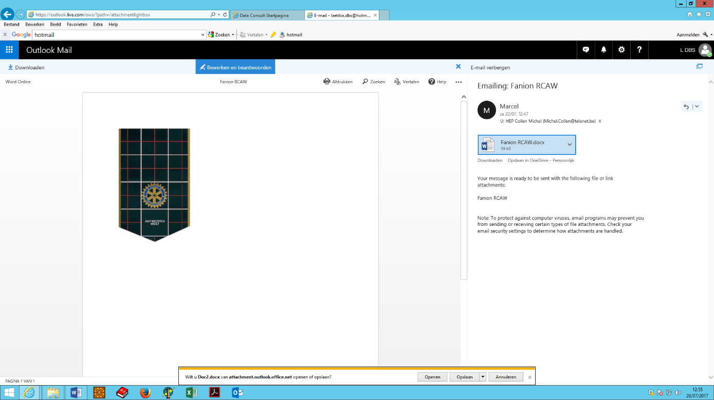

[**www.resonance-icc.org**](http://www.resonance-icc.org)

Dinsdag 03 maart 2020

AMUZ, Kammenstraat 81, Antwerpen   
Aanvang: 20.00u

Inkom prijs 30, -€

Met

***Ihor Vydoinyk*  *(20/05/1994)* *flute Ukraine, Odessa***

***Vladyslav Dolhiier (08/09/1997) cello Ukraine***

***Stanislava Zagidulina 24/05/1999 piano Russia***

***Sofiya Vnukova (08/03/1996) violin Russia,***

**Elena Gevorkian – Begeleister**



Reservaties bij de leden van Antwerpen Ring of West ook direct via

[Michel.collen@telenet.be](mailto:Michel.collen@telenet.be)

*BESTELBON*

CONCERT RESONANCE

Dinsdag 03 maart 2020

AMUZ Kammenstraat a Antwerpen 20:00H

***NAAM …………………………………………………………………………………………***

***VOORNAAN…………………………………………………………………………………...***

***ADRES+POSTCODE……………………………………………………………………………………………………………………………………………………………………………***

***TEL of GSM……………………………………………***

***E-mail………………………………………………….***

|  |  |  |  |
| --- | --- | --- | --- |
| Concert | Eenheidsprijs | Aantal | Totaal bedrag |
| Resonance Concert | 30.00 € |  |  |

***Terug te sturen naar*** [***michel.collen@telenet.be***](mailto:michel.collen@telenet.be)

***BETALEN***

***Rekening N° BNP PARISBAS-FORTIS***

***Rotary Marcel Zuckerman***

***BE13 0015 7923 1839-***

***BIC: GEBABEBB***

***\*\*Plaatsen zijn beperkt tot 285***

***\*\*Betaling is een reservering***



[**www.resonance-icc.org**](http://www.resonance-icc.org)

MUZIKAAL PROGRAMMA

CONCERT PROGRAM « RESONANCE 6 » 2020

PART I

***Ihor Vydoinyk*** *-* ***flute*** *Ukraine, Odessa State Academy of Music*

- С. Stamitz: Flute Concerto in G major, Op.29, 1st mvt.

- Ph. Gaubert : Nocturne et Allegro Scherzando

- G. Schocker: “Regrets and Resolutions”

***Vladyslav Dolhiier******-cello*** *Ukraine, Odessa State Academy of Music*

- N.Paganini: Variations on a theme from “Moses in Egypt”

- P.Tchaikovsky: Pezzo capriccioso

- K.Popper: Dance of the Elves

- D. Shostakovich: Concertо N 1 in E-flat major, op.107, 1st mvt.

PART 2

***Stanislava Zagidulina*** *–* ***piano*** *Russia, St.Petersburg State Conservatory*

- R. Schumann: 3 pieces of Fantasiestücke, op.12 (“Des Abends”, Aufschwung”, ”Traumes Wirren”)

- I. Stravinsky: Three Movements from the ballet “Petrushka”- “Russian Dance”, “

Petruska’s Room”, ”The Shrovetide Fair” (transcribed for piano by the composer)

***Sofiya Vnukova****) –* ***violin*** *Russia, Moscow State Conservatory*

- L.Beethoven: Sonata N 8 in G major, op. 30 No 3, 1st mvt.

- N. Paganini: “La Campanella” (Concerto N 2 in B minor, op.7, 3st mvt.)

- H. Wieniawski: Variations on an Original Theme

**Elena Gevorkian - accompanist**